Standard Operating Procedure
High Mast Installation



ODISHA MINING CORPORATION LTD.
KODINGAMALI BAUXITE MINE

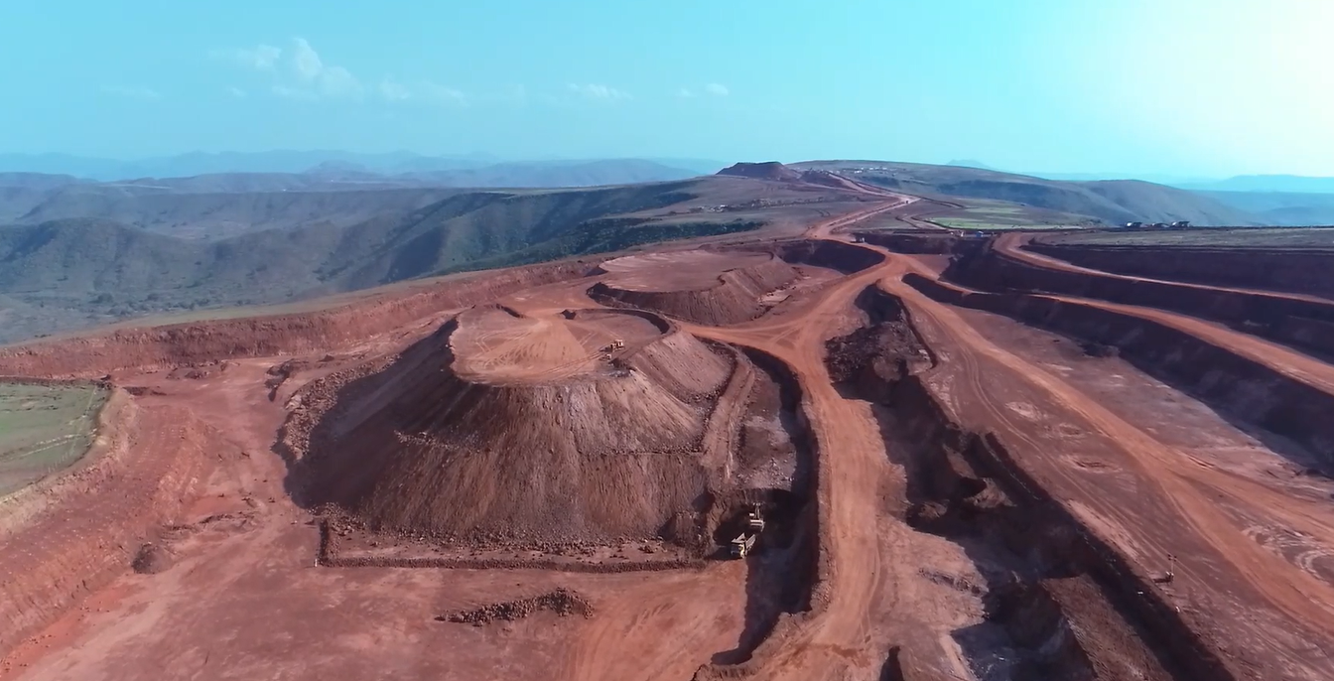

Authorized By

PURPOSE:
The purpose of this procedure is to provide the details of installation of High mast system & other miscellaneous items like wire rope, Trailing cables, winch, motors, Head frame, and Luminaire carriage set in Kodingamali Bauxite Mine.

- SCOPE:
This procedure is covers methods of installation of High mast and other miscellaneous items in Kodingamali Bauxite Mine.

- RESPONSIBILITY:
 | Diesel generator | D. G. Operator
 | D. G. Maintenance | Maintenance Mech. / Ele. Incharge
 | Field Operation | Supervisor/Shift Incharge
 | Operational Control | Area in-charge

- SAFETY AND HEALTH HAZARDS:
- Slip/trip/fall.
- Head on Collision.
- Toppling of High mast light.
- Toppling chances.(level of install base point)
- Rain protection on the light DB.
- Hydraulic Oil - Inflammable, Fire hazards.
- Acid Batteries- Skin contact can lead to extensive and severe burns and highly toxic.

In order to avoid injuries to personal and damage to high mast light, the following precautions are very important.
- Work required PPE i.e. with safety shoes, helmet, dust musk, shock proof hand gloves, fluorescent jacket suitable for long distance visibility etc.
- Pre Operation Safety features checklist.
- Regular Checks & Maintenance.

Note: Report immediately to Supervisor, Shift Incharge and Safety officer for any incident/accident.

- ENVIRONMENT ASPECT:

- Dust generation
- Noise Pollution
- Vibration, Trembling (support provide 4th direction)
- Oil Spillage
Preventive measures:
- Regular use blowers for dust control.
- Use of Dust Mask/Earplug
Control of leakages

- TOOLS AND TACKLES:
All Work required PPEs like Safety Helmet, Safety shoes, Nose mask, Ear Plug, shock proof hand gloves & Jacket.
2/3/5 Ton capacity chain pulley block, Steel rod (sabbal), Spanner set, Combination pliers, Insulation remover, Screwdriver set, Line Tester, megger, Multimeter.
Hydra – Capacity 8 Ton
Crane – Capacity 20 Ton, Boom length – 45 ft.
Wire rope – sling 12 mm
Belt – Not used

- PROCEDURE:

Experienced persons should be employed for the job. Ensure that persons running the High mast light are equipped with safety helmet.
- Do not stand under the load and within the operating radius of cranes.
- Check quality size and condition of all the chain pulley blocks, slings, U clamps, D shackles and wire rope etc. The same should not be damaged.
- Safe working load shall be marked on all lifting equipment’s.
- Crane and all lifting gears should be tested by third party competent person.
- Proper guiding and signaling to crane operator.
- Tag line to be used during erection of High mast Tower.
- Tag line to be used during loading / unloading / shifting the material.
- All electrical connections must be away from water sources.
- Routine wise checking cleaning of all electrical panels should be made as per check.
- Routine wise electrical safety audit should be made as per checklist.
- Proper checking of earthing connection should be made and ELCB to be provided on outgoing cable.

SHUT DOWN:
- Install the machine in safe place.
- Switch off all apparatus which work on electricity or engine.
- Remove ignition key & lock the cabin.

